**HEAVY DUTY INDUSTRIAL FANS:**

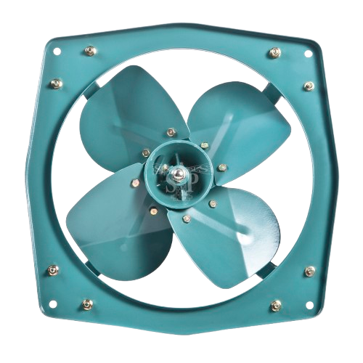

**Price: 14,700.00**

The Heavy Duty Industrial Fan is a robust and reliable ventilation solution, designed to withstand the rigors of demanding industrial environments. With its powerful motor, rugged construction, and durable components, this fan delivers high-volume airflow and intense air circulation, effectively cooling large areas and improving air quality. Its adjustable speed settings, corrosion-resistant coating, and easy maintenance design make it an ideal choice for harsh industrial settings, such as factories, warehouses, and manufacturing facilities.

**Key features of heavy duty industrial fans include:**

* **High Airflow Capacity** – Moves large volumes of air efficiently.
* **Durability** – Made from robust materials for harsh environments.
* **Powerful Motors** – Delivers strong, consistent airflow.
* **Energy Efficiency** – Optimizes energy usage to reduce costs.
* **Corrosion Resistance** – Coated to withstand moisture and chemicals.
* **Variable Speed Control** – Adjustable airflow for different needs.
* **Low Maintenance** – Designed for long life and minimal upkeep.
* **High Static Pressure Capability** – Effective in high-resistance environments.
* **Noise Reduction** – Features to minimize operational noise.
* **Safety Features** – Includes thermal overload protection and safety guards.